**Java Web开发**

**实验八**

**作业报告**

|  |  |
| --- | --- |
| 学 院 | 计算机 |
| 所在系 班 级 | 2017软件工程系6班 |
| 学 号 姓 名 | 李梓华 |
| 指 导 教 师 | 郭晓燕 |
| 完 成 时 间 | 2019年5月5日 |

# 实验题目

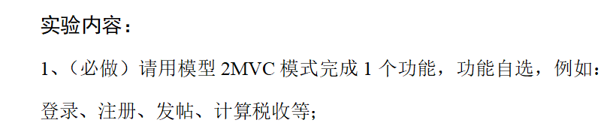

# 分析与设计

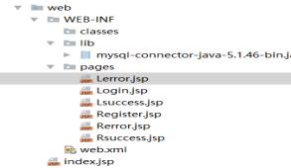

# 关键源码（部分）

package com.lala.dao;

import java.sql.ResultSet;

import java.sql.DriverManager;

import java.sql.SQLException;

import com.lala.bean.User;

import com.mysql.jdbc.Connection;

import com.mysql.jdbc.PreparedStatement;

public class UserDAO {

Public static final String DBurl = "jdbc:mysql://127.0.0.1/test?characterEncoding=utf8&useSSL=true";

public static final String DBname = "com.mysql.jdbc.Driver";

public static final String DBuser = "root";

public static final String DBpassword = "root";

public User login(int id,String password) {

User u = null;

Connection connection =null;

PreparedStatement pstmt=null;

ResultSet resultSet=null;

//赋值

try {

try {

Class.forName(DBname);//指定连接类型

connection = (Connection)DriverManager.getConnection(DBurl, DBuser, DBpassword);//获取连接

} catch (ClassNotFoundException e) {

e.printStackTrace();

}

//静态sql语句

String sql = "select * from user where id=? and password=?";

pstmt = (PreparedStatement) connection.prepareStatement(sql);

pstmt.setInt(1, id);

pstmt.setString(2, password);

resultSet = pstmt.executeQuery();

if(resultSet.next()){

u=new User();

u.setId(resultSet.getInt("id"));

u.setName(resultSet.getString("name"));

u.setPassword(resultSet.getString("password"));

u.setRole(resultSet.getInt("role"));

System.out.println("登录成功！");

}else{

System.out.println("用户名或者密码错误！");

}

} catch (SQLException e) {

e.printStackTrace();

}finally {

if(pstmt !=null){

try {

pstmt.close();

} catch (SQLException e) {

// TODO Auto-generated catch block

e.printStackTrace();

}

}

if(connection !=null){

try {

connection.close();

} catch (SQLException e) {

// TODO Auto-generated catch block

e.printStackTrace();

}

}

}

return u;

}

public boolean addUser(User u) {

Connection connection = null;

PreparedStatement psmt = null;

boolean boo = false;

try {

try {

Class.forName(DBname);//指定连接类型

connection = (Connection)DriverManager.getConnection(DBurl, DBuser, DBpassword);//获取连接

} catch (ClassNotFoundException e) {

e.printStackTrace();

}

String sql ="insert into user(id,name,password,role)values(?,?,?,?);";

psmt = (PreparedStatement) connection.prepareStatement(sql);

//运用实体对象进行参数赋值

psmt.setInt(1, u.getId());

psmt.setString(2, u.getName());

psmt.setString(3,u.getPassword());

psmt.setInt(4, u.getRole());

int result = psmt.executeUpdate();

if(result > 0){

boo = true;

System.out.println("插入数据成功");

}else{

System.out.println("未插入数据");

}

} catch (SQLException e) {

// TODO Auto-generated catch block

e.printStackTrace();

}finally {

try {

connection.close();

psmt.close();

} catch (SQLException e) {

e.printStackTrace();

}

}

return boo;

}

}

# 运行效果图

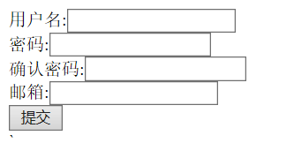

1557066303(1)

# 收获与问题

通过本次实验我懂得了MVC模式的使用